Participant Name |  | Prepared By:
Date Prepared |  | Date Reviewed:

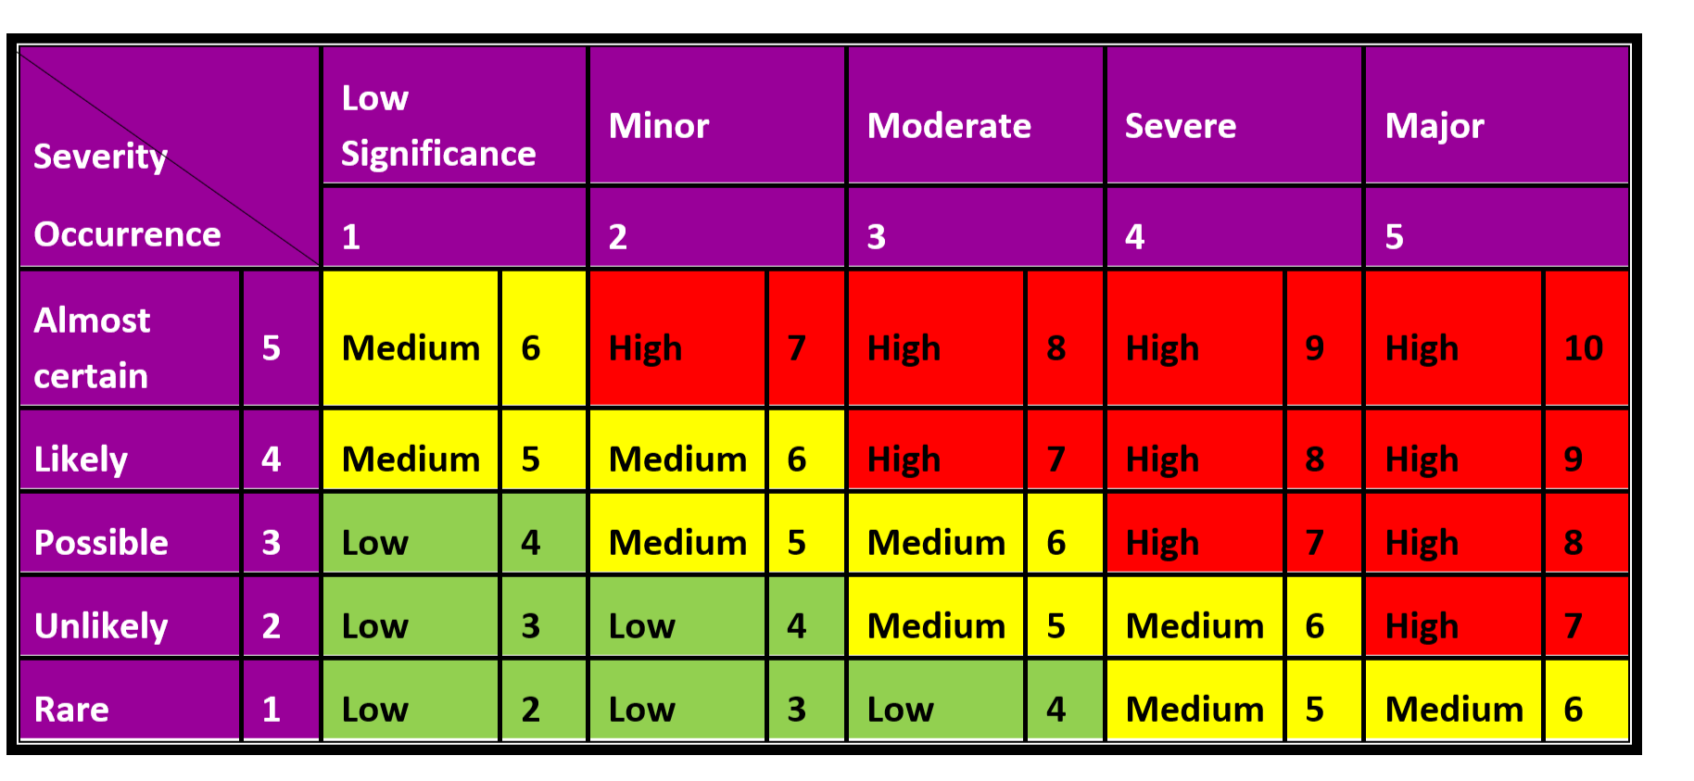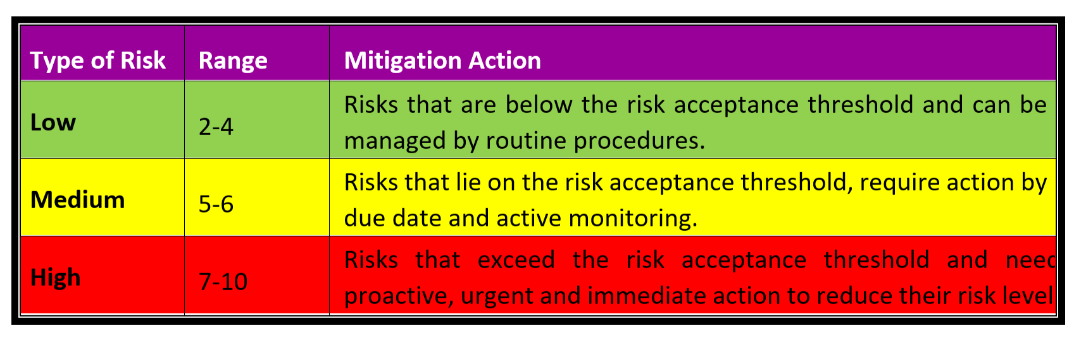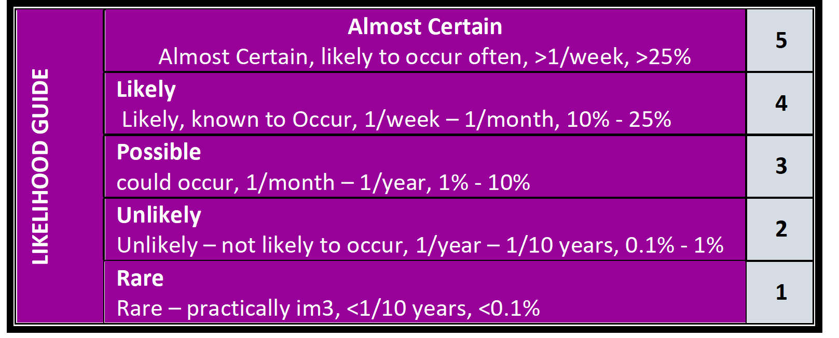

No. | Risk Areas | Risk To self | Risk Category  (H,M,L) | Risk To Staff | Risk Category  (H,M,L) | Risk To Other | Risk Category  (H,M,L) | Source Of  Information | Comments  (management or support plan )
Behaviours
- Self-harm
- suicide risk
- Assault – Physical
- Assault - verbal
- Sexual; predatory
Accidental Movement
- Startle reflex
- Panic behaviour
- Grabbing, holding, leaning
- Sudden body movements
- Falling, bumping
- Tripping, running
Resistance to
Support during Activities of Daily Living.
- Feeding
- Toileting
- Grooming
Resistance to
Support during Activities of Daily Living.
- Feeding
- Toileting
- Grooming
Unsafe Action
- Gambling
- Drugs, medications
- Unsafe sex
- Alcohol
- Smoking
- Criminal activity
- Wander, abscond

Hazard Exposure
- Electricity
- Fire lighting
- Sharps
- Flammables, poisons
- Water hazard, bathing
- Sun exposure
- Slamming doors
Environmental &
Social
- Traffic, roads
- Travel, riding in vehicle
- Travel in public transport
- Stranger danger
- Other clients
- Family, carers
- Cultural, linguistic, religious
Recurrent Medical
- /Health Conditions
- Dysphagia – choking on food or saliva
- Choking from poor positioning
- Overnight feeds req.
- Fractures, bruising,
- Seizures
- Respiratory condition
- Allergies -
- Skin Condition
- Diabetes
- Incontinence
- Mental Illness
- Drug addiction
Infectious Diseases
- Chronic
- Recurrent
- Other
9. Other
e.g. waiting in
medical/dental
facilities

Documentation and Management approval
Completed by: (name) (signature) Authorised by: (name) (signature) Date:

Monitor and review the risk controls
Review date: Reviewed by: Authorised by:
Review date: Reviewed by: Authorised by:
Review date: Reviewed by: Authorised by:
Review date: Reviewed by: Authorised by:
Review date: Reviewed by: Authorised by:

